Web Development POEP2

Website-CSS

WEDE5020

Siyamthanda Mkhatshwa

ST10459640

Group 2

**Table of Contents**

Screenshots of output on different screen sizes. 2

References: 5

Figure 1: website displayed in iPhone XR view. (Mobile screen size). 2

Figure 2: website displayed in iPad Mini view. (Tablet screen size). 3

Figure 3: website displayed in laptop view. (Laptop screen size). 4

# Screenshots of output on different screen sizes.

The use of CSS for styling and responsiveness.

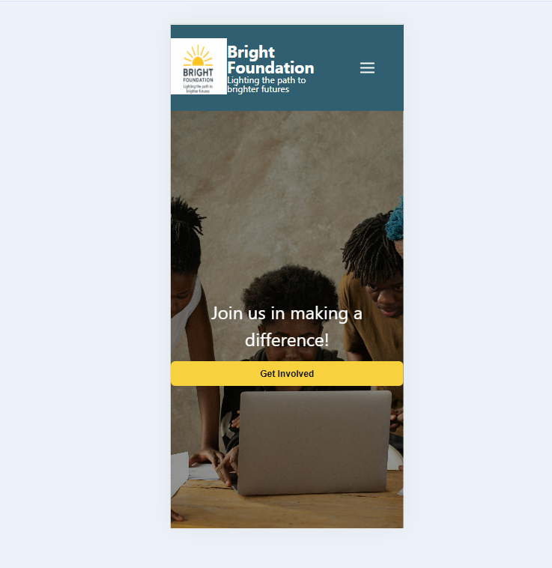

Figure 1: website displayed in iPhone XR view. (Mobile screen size).

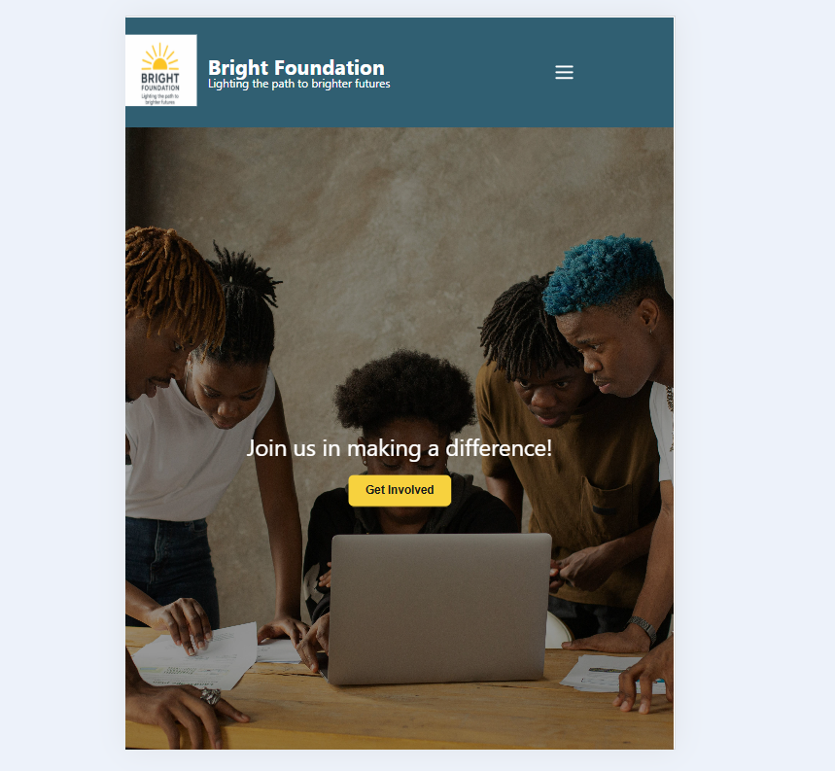

Figure : website displayed in iPad Mini view. (Tablet screen size).

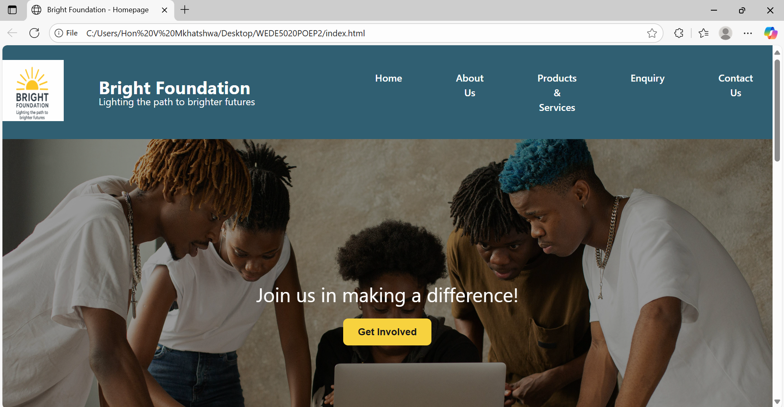

Figure : website displayed in laptop view. (Laptop screen size).

# References:

• ChatGPT (2025) *Guidance on website navigation, layout structure, and responsive adjustments*. OpenAI GPT-5. Available at: <https://chat.openai.com/> (Accessed: 22 September 2025).

• Class Exercises (2025) *Additional CSS styling ideas*. [Web development (WEDE5020)].

• W3Schools (2025) *CSS Tutorial*. W3Schools. Available at: <https://www.w3schools.com/css/> (Accessed: 25 September 2025).

• W3Schools (2025) *Font Awesome Icons – Brands*. W3Schools. Available at: <https://www.w3schools.com/icons/fontawesome_icons_brand.asp> (Accessed: 25 September 2025).